JURNAL MODUL 13

Nama: Zhafir Zaidan Avail

NIM: 2311104059

Hasil Run:

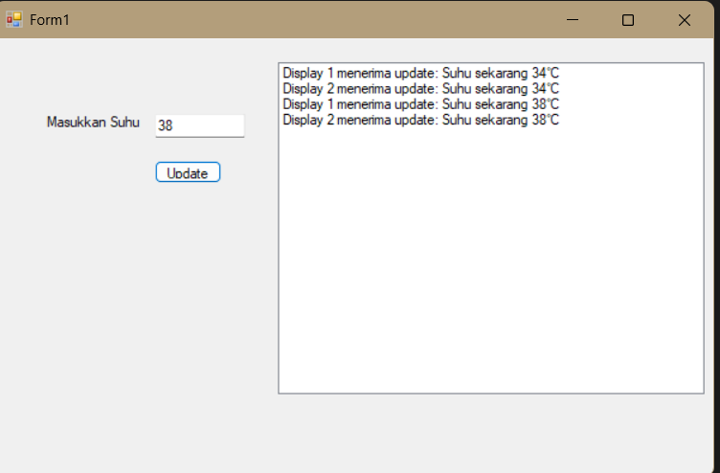

Struktur:

TJ13_2311104059/

│

├── IObserver.cs

├── ISubject.cs

├── WeatherStation.cs

├── DisplayDevice.cs

├── Form1.cs (GUI + logic)

├── Program.cs

Buat Interface: IObserver dan ISubject

--IObserver.cs--

public interface IObserver

{

void Update(float temperature);

}

--ISubject.cs--

public interface ISubject

{

void RegisterObserver(IObserver observer);

void RemoveObserver(IObserver observer);

void NotifyObservers();

}

Buat Subject: WeatherStation.cs

using System.Collections.Generic;

public class WeatherStation : ISubject

{

private List<IObserver> observers = new List<IObserver>();

private float temperature;

public void RegisterObserver(IObserver observer)

{

observers.Add(observer);

}

public void RemoveObserver(IObserver observer)

{

observers.Remove(observer);

}

public void NotifyObservers()

{

foreach (var observer in observers)

{

observer.Update(temperature);

}

}

public void SetTemperature(float temp)

{

this.temperature = temp;

NotifyObservers();

}

}

Buat Observer: DisplayDevice.cs

using System.Windows.Forms;

public class DisplayDevice : IObserver

{

private string deviceName;

private ListBox outputBox;

public DisplayDevice(string name, ListBox listBox)

{

deviceName = name;

outputBox = listBox;

}

public void Update(float temperature)

{

outputBox.Items.Add($"{deviceName} menerima update: Suhu sekarang {temperature}°C");

}

}

Kode di Form1.cs

using System;

using System.Windows.Forms;

namespace ObserverWeatherApp

{

public partial class Form1 : Form

{

private WeatherStation weatherStation;

private DisplayDevice display1;

private DisplayDevice display2;

public Form1()

{

InitializeComponent();

weatherStation = new WeatherStation();

display1 = new DisplayDevice("Display 1", listBoxOutput);

display2 = new DisplayDevice("Display 2", listBoxOutput);

weatherStation.RegisterObserver(display1);

weatherStation.RegisterObserver(display2);

}

private void btnUpdate_Click(object sender, EventArgs e)

{

if (float.TryParse(txtSuhu.Text, out float suhu))

{

weatherStation.SetTemperature(suhu);

}

else

{

MessageBox.Show("Masukkan suhu yang valid!", "Error", MessageBoxButtons.OK, MessageBoxIcon.Error);

}

}

}

}